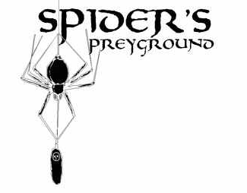
Spiders Preyground 2005
Haunt Definition Document
Document History: Draft 15f, Aug 16, 2005
Table of Contents
Introduction 2
2005 Event Information 2
Proposed Times & Dates of Operation 2
Cast 3
Optional cast 3
Haunt Synopsis (back story) 3
Structure of the haunt 4
Pre-Haunt areas 4
Concessions 4
Line Area 4
Main Haunt Area 4
Floor plan (draft, not to scale) 5
Room 1- Reception Area 6
Room 2/3- Arachnid Research Lab 6
Room 4- Infirmary 7
Room 5- Specimen Room 8
Room 6- Cocoon Hallway 8
Room 7- Vortex Tunnel 9
Room 8- Decontamination Chamber 9
Room 9- Giant Spider Reveal 9
Contact Information: 10

Introduction
The Spiders Preyground is a haunted attraction concept designed by Vern & Kym Graner of Austin, Texas. In 2004, the Spiders Preyground was entered in the International Haunters Choice Awards and not only won “1st Place” in the “Home Haunt” division, but was also the winner of the “Grand Prize” for the year. Now, in our second year of operation, the Spiders Preyground will be thrilling guests with bigger effects, more actors, and new spooky surprises!

The Spiders Preyground is based around the mythical “B0rkin Pest Control” company and their secret Research and Development laboratories. Due to negative media attention when “Giant Spider” rumors began to circulate, B0rkin has decided to allow visitors through it's facility in an attempt to calm the fears of the local residents. During the Public Relations tour through the facilities, guests will witness what is obviously a complete failure of the company to grasp what is rapidly becoming a major disaster involving nuclear waste, corporate conspiracies and, of course, giant venomous spiders.

2005 Event Information
- Name: Spiders Preyground
- Event: Haunted Attraction
- Genre: “B” movie style Science Fiction
- Rating: PG (monsters, “startle” scares)
- Website: http://www.spiderspreyground.com
- Location: To Be Determined
- Sponsor: To Be Determined
- Days Open: 5 (or 10)
- Hours Open: 23.5 (or 44)
- Construction: October 1st-18th (tentative)
- Dress Rehearsal: October 27th (5 day) or October 20th (10 day)

Proposed Times & Dates of Operation
Day | DOW | Date | Open | Close
 | Thursday | October 20 | Dress Rehearsal | Press Night
1 | Friday | October 21 | 7:00pm | 12:00am (5 hrs)
2 | Saturday | October 22 | 7:00pm | 12:00am (5 hrs)
3 | Sunday | October 23 | 7:00pm | 10:30pm (3.5 hrs)
4 | Tuesday | October 25 | 7:00pm | 10:30pm (3.5 hrs)
5 | Wednesday | October 26 | 7:00pm | 10:30pm (3.5 hrs)
6 | Thursday | October 27 | 7:00pm | 10:30pm (3.5 hrs)
7 | Friday | October 28 | 7:00pm | 12:00am (5 hrs)
8 | Saturday | October 29 | 7:00pm | 12:00am (5 hrs)
9 | Sunday | October 30 | 7:00pm | 12:00am (5 hrs)
10 | Monday | October 31 | 7:00pm | 12:00am (5 hrs)

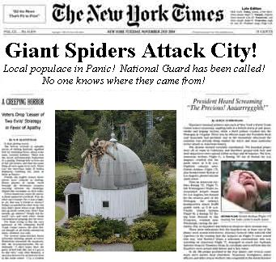
Cast
- Receptionist
- 2x Tour Guide (Lead)
- 2x Tour Guide (Rear guard)
- Mad Scientist
- Spider Queen (demanding role w/ puppeteering )
- Morgue/Infirmary Monsters
- Security (”chicken” guide)
- “Spider Sliders”

Optional cast
- Mad Scientist assistant
- Extra Infirmary/Morgue monsters
- Infirmary doctor/nurse/victim

Haunt Synopsis (back story)
The Spiders Preyground is based around a fictional extermination company called “B0rkin Pest Control” (note: the second character in the B0rkin name is a number “zero” and not the letter “Oh”). B0rkin is a subsidiary of the larger “Parasol” corporation (nod to resident evil) that deals with, among other things, disposing of radioactive industrial waste.

It has come to the attention of the media that a correlation may be drawn between areas “treated” by B0rkins new pest control products and instances of disappearing pets and people suffering from a strange affliction doctors have not been able to diagnose or cure. Further investigation reveals that people in and around some of the treated residences have been found in a semi conscious state, suffering from delirium, greatly reduced vital signs and evidence of what appear to be spider bites.

Many of those affected have been heard to claim they were attacked by fast moving “giant spiders”. When more lucid, they describe a feeling of “changing” and a disquieting hunger for human flesh. If left untreated, these people eventually either cease to display any vital signs or in some cases mutate into giant spiders. In an effort to further their research (and to keep the situation “quiet”) B0rkin has collected all of these affected individuals and brought them to their Corporate Research Facility for treatment and observation.

Now, with the media spotlight on them, the B0rkin Corporation goes into “SPIN” control mode and tries to mitigate the P.R. damage by having carefully staged and guided tours of their otherwise Top Secret Research and Development Center. Though admitting they have “recycled” the otherwise “useless” nuclear waste material into “useful” pesticides, they describe the “giant mutant spiders” as an exaggeration and people turning into so-called “spider zombies” and these “giant spiders” as “ridiculous exaggerations”. Some of the people affected (described as “Living Challenged” by B0rkin spin control) are being treated in B0rkin's state of the art Hospital/Infirmary and are “showing improvement” through a combination of experimental drugs and exposure to ultra-violet (black) light. B0rkin describes the spider bite effects on people as an unfortunate, “minor” side effect to this fantastic new pesticide they have developed.

They try to spin the crisis by making it seem as if they are making great strides in controlling and reversing the effects of the spider venom on it's victims. By keeping the victims and the spiders (at least the ones they've managed to capture) in a quarantined area, and exposing them to UV light (black light) they claim they have greatly slowed, and in some cases, reversed the effects of the spider venom. The spiders are so effected by the black light, that B0rkin claims they become sluggish and/or fall asleep when exposed to this type of light. However, recent evidence seems to indicate they may not only be gaining immunity to it, but some even seem to thrive on it.

Structure of the haunt

Pre-Haunt areas
Please Note: In the following sections, some photographs have been supplied to act as “placeholders” and as illustrations to help visualize how how the section should appear!

Concessions
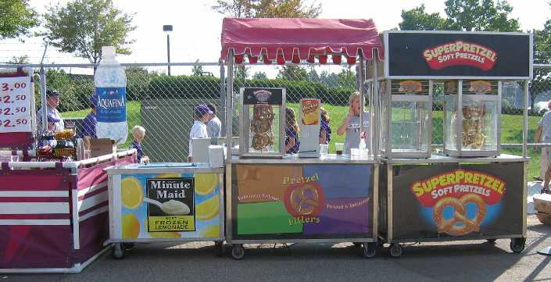
As a way to generate additional revenue and to “kill time” while waiting in line, it would be possible to have various concessions set up to sell multiple high-profit items such as food, drinks and merchandise like t-shirts, hats, bandannas, small rubber spiders, glow necklaces & bracelets etc. In order to draw in those who might be unaware of the event, if possible, we should try and have “search lights” and an FM transmitter setup to broadcast a repeating message about the event, the times of operation and the cost.

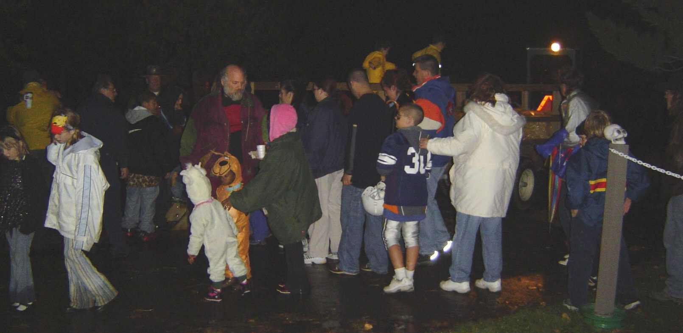
Line Area
As a way to build suspense and to prepare the guests for the haunt, TV monitors could be set up with various false “newscasts” that would provide back story to the event and help to get the guests familiar with the basic story that supports the haunt they are about to enter. Possible tie-in to live video from inside the haunt.

Main Haunt Area

Floor plan (draft, not to scale)
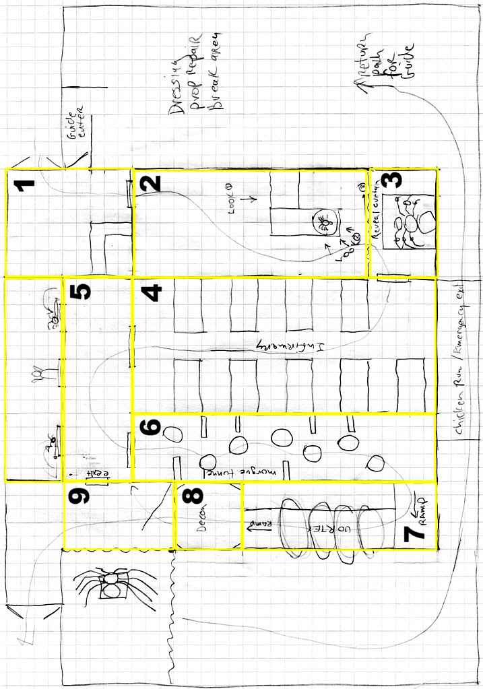

Room 1- Reception Area
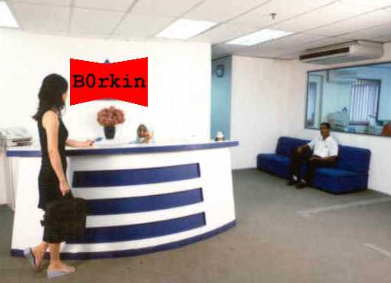
This is just inside the door and the first place the guests are able to meet with B0rkin personnel. A rather bored yet perky young receptionist rattles off the canned greeting, and introduces you to your guide. The obnoxiously bouncy, perky, spin-tastic P.R. Guide gushes about how great it is to meet you and how anxious he is to show you how B0rkin has everything under control (Idea: A few well timed eye-rolls from the bored receptionist reveals her opinion of him as just a PR flunky. Maybe enhance this with “thank you Tracey!” “Thats Tanya!” “certainly Tracey.” dialog) Once the group is assembled we wait for a “sync phone” ring as a signal to have the group enter with the guide. The receptionist will answer the phone and then tell the guide to go in. The sync ring will be audible throughout the haunt to make sure all guides know when to move to the next rooms. (The ring should be triggered when the guide in the Specimen room hits the “alarm”.) Note: The receptionist will double as security coordinator and will have the ability to “shutdown” the haunt and bring up house lights in the case of an emergency.

Room 2/3- Arachnid Research Lab
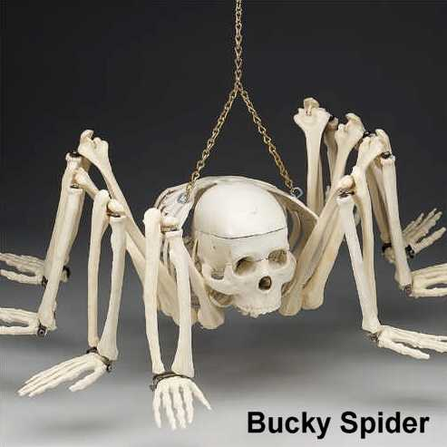
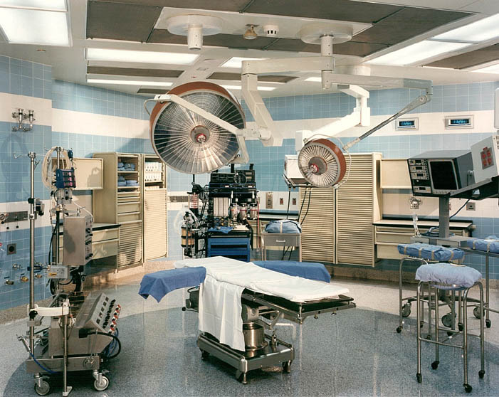
The Arachnid Research Lab is a medical research/diagnostic lab where a scientist (arachnologist) is experimenting with the spiders and victims of the spiders in various stages of their transformation. This is a crucial room in the haunt as much of the foreshadowing for later effects are performed here. Foreshadowing clues are noted in italics in this section. The key character in this room is the Arachnologist. He should exhibit a disquieting enthusiasm in the scientific aspects of the problem with little or no regard for the human toll on the victims. He will have a number of props to use during his performance. There will be a bubbling “pool” of viscous fluid where a “Bucky Spider” (see illustration) is submerged. The “Bucky Spider” is then slowly drawn into view by the doctor as he describes the process that causes a victims “DNA” to slowly convert to that of a spider causing these interesting half spider/half human hybrids. The “Bucky spider” is one of the “unfortunate ones” that didn't survive the conversion back to human, but has nonetheless provided a useful medical specimen for examination by others in the scientific community. Next, there is an aquarium-like specimen cage with a rotating ring bisecting it. There will clearly be spiders on one side of the ring, and NONE on the other. The scientist will explain this makes an effective deterrent to spiders, hence the reason none will pass through the rotating ring. He then goes on to boast of a full size unit (the vortex tunnel, room 6) he invented that is big enough for humans to use, but that would only be in direst emergency as he's not sure what effect it would have on people. Next, he would show a full-size “Bucky” skeleton wrapped in webs and suspended for view. He goes on to describe how the female spiders would paralyze and then wrap victims alive, suspending them from the ceiling (cocoon hallway, room 5). They would then lay their eggs on the bodies providing a feast for the baby spiders when they hatch, eating the unfortunate victim alive, leaving only a dried husk behind.
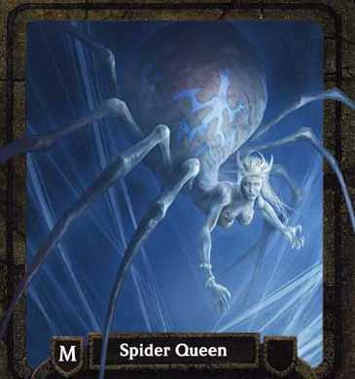
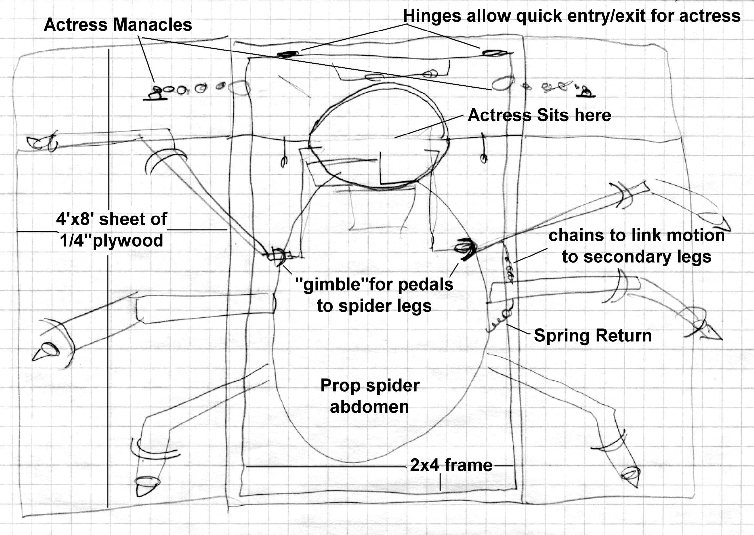
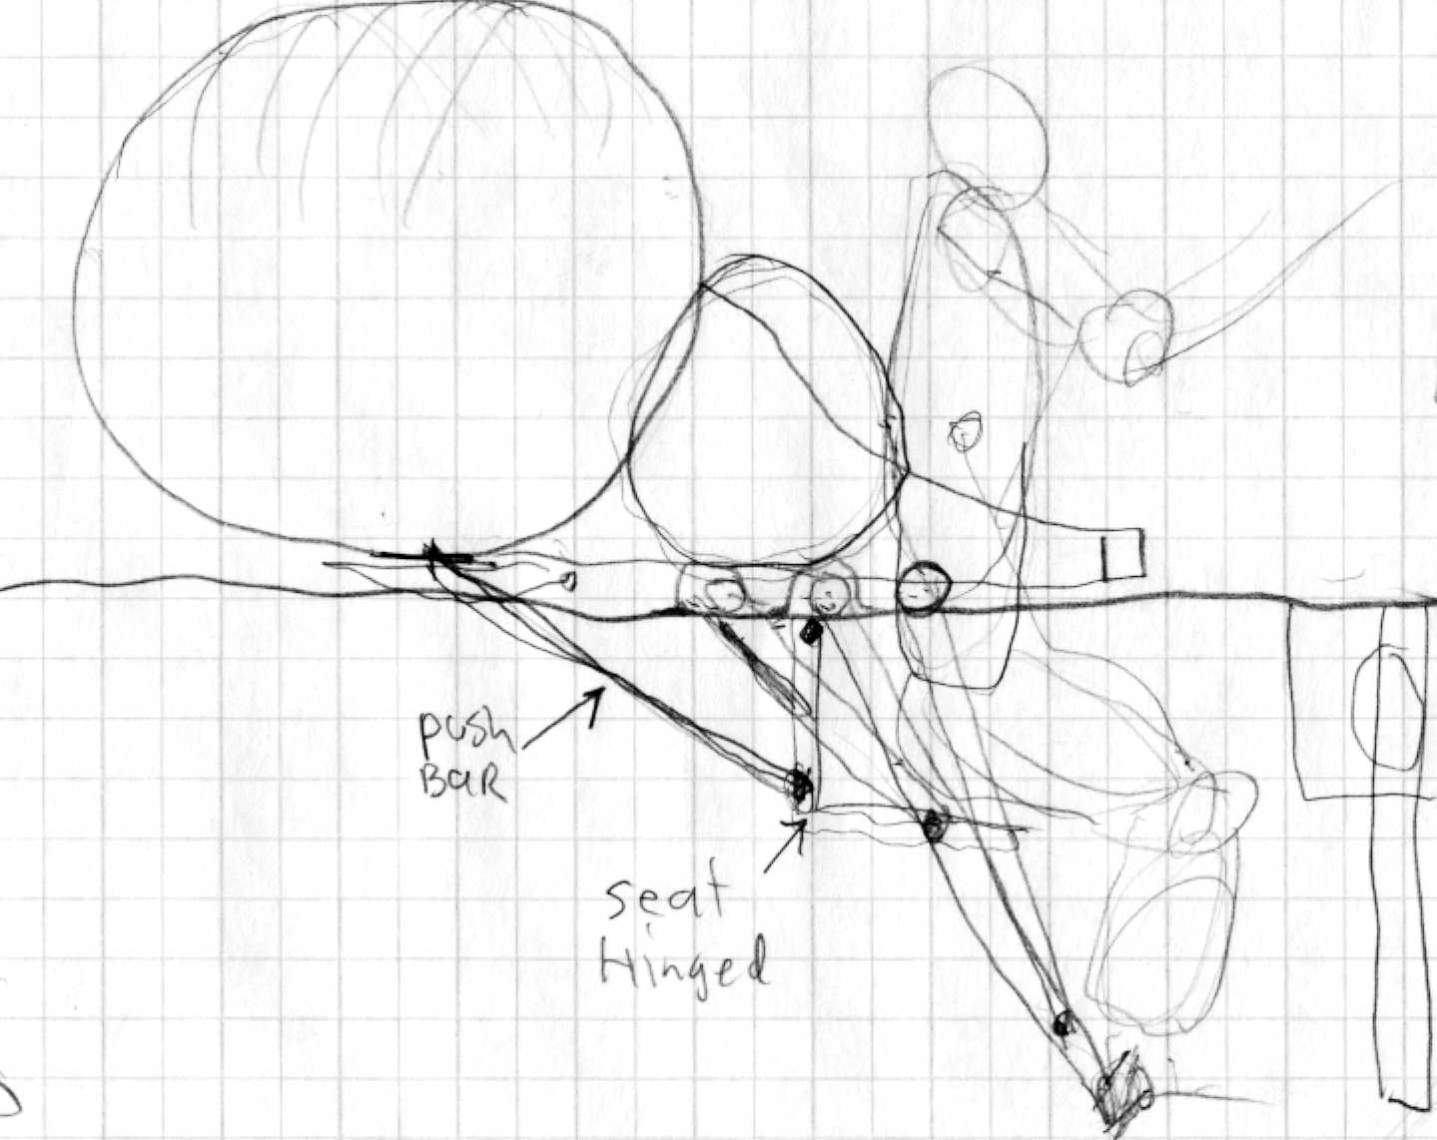
The highlight of this room will be a large “bed” (approximately 12'x8') that holds a very large half spider/ half human girl character (See “spider queen” illustration). The “bed” will reveal the “top half” of the girl (from the waist up) wearing a lab coat or nurses uniform. All of the “prop” spider legs behind her will be loosely manacled to the table and her wrists will also be manacled to the table, but allow her enough reach so she can move her arms around. The table will have a “seat” allowing the actress to use her legs/feet to swing the rear spider legs by placing her feet on “pedals” that connect to the PVC legs. his will make the prop a sort of “puppet” operated by the actress. The left arm of the actress will be sleeved and seen by the guests, but her right arm will be a “fake” and manacled to the table. Her real right arm will be inside a sleeve of fur and run up into a spider puppet that she can have “crawl” around her lap, or she may cuddle like a baby. She could pet and “coo” to it or possibly have it ”jump” towards the guests using her “real” arm to retrieve it before it gets away. Good opportunity for scares. See ROUGH sketches of approximate design for details, The table will be screened from view and dramatically revealed by the doctor. He introduces the girl who was his lab assistant/nurse who, after an “unfortunate incident”, is partially transformed into a spider/human hybrid. The Arachnologist will go out of his way to warn everyone about how toxic the venom is and also to describe the fascinating behavior of the spiders and their ability to “spray” the venom on anyone that comes into range and frankly, he's not really sure just how far away you have to be in order to be safe. It was suggested the scene end when the doctor says “it's time for me give this patient another treatment” and either A) the spider girl becomes agitated and tries to attack him or B) he retreats behind the curtain with the Spider Queen and various noises could indicate a struggle.

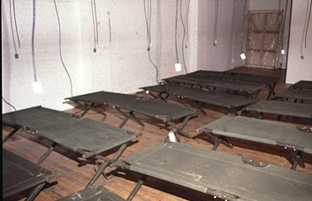
Room 4- Infirmary
The infirmary will have a long row of army cots with bodies under blankets or sheets with the various bodies either lying motionless, or wiggling and/or pleading for help. In some cases, the cots will be occupied by actors that may writhe and moan, or drop an arm out from under the sheet or otherwise do “creepy” or “boo” scares. This is also an opportunity to use the air cylinder “elbows” to create less-than-human motions from under the blankets.

Room 5- Specimen Room
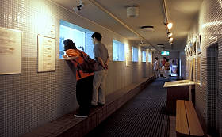
The specimen room will have viewing windows where wire cloth will separate the guests from the boxes, crates and packing material where the spiders are being shipped to this facility, and from this facility to other locations world-wide for study. As the PR guide explains that “every specimen is kept securely in it's own bio-container”, the guests begin to notice that there are quite a few open containers! One in fact is shuddering and smoking and it's clear that something is about to make it's way out. There is also evidence of containers that have burst open and, other than webs everywhere, there are no spiders to be seen!. As the guests look for the spiders, the first spider slammer smashes against the wire mesh and the guests are “sprayed” with spider venom. Freaked out by this unexpected attack, the P.R. Guide hits the Emergency Alarm Switch and tells everyone they have to get to the emergency decontamination station immediately. The quickest way to get there is through this emergency exit. The guests follow the guide into the emergency exit door and into a darkened hallway.

Room 6- Cocoon Hallway
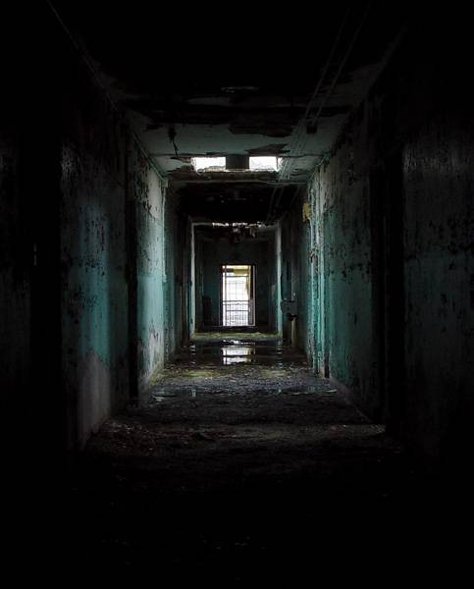
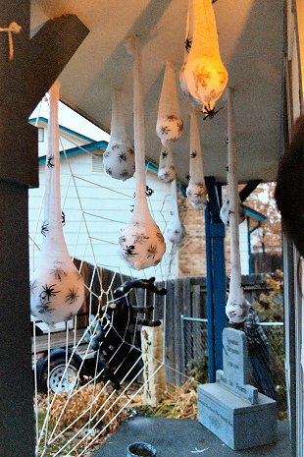
The Cocoon Hallway is a dark hallway covered in thick spider webs where bodies and spider eggs hang from the ceiling in spider web cocoons. A fog chiller vents into a piece of “French drain” pipe that distributes the fog over the entire length of the hallway. The body bags will be equipped with pneumatic “elbows” that will cause the bag to “flex” or “twitch” at random. Some spiders will be clearly visible and webs are everywhere. Along the bottom edges of the room will be some crouched spiders about as big as garbage can lids. The hallway will have “step mats” that will sense when a person is close enough to an effect to activate it. For example, as people walk past, the front to legs of the spiders will “flail about” as the spiders “hiss” at the people. At the end of the hallway, there will be a clearly lighted sign that says “DECONTAMINATION AREA”. Note: as this is near the “center” of the haunt it might be interesting to build a chair “perch” where a cast member could sit and toss small black plastic spiders down onto the guests as they pass through areas of the haunt. This entire section should be very dark. There will be an ominous sound track playing through speakers along with some reverb laden effects that will add to the abandoned, industrial feel and the feeling of other “things” being in here with you.

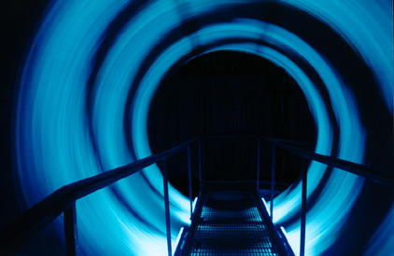
Room 7- Vortex Tunnel
As the guests exit the Cocoon Hallway, they see a ramp leading to the Vortex Tunnel. The Vortex Tunnel will be spinning and making ominous noises of buzzing and clacking. They proceed up the ramp and turn 90 degrees to enter the tunnel itself. A bridge goes through the tunnel and the rotating rings are reminiscent of the rotating rings shown by the arachnologist in the lab in room 2. The interior is lit with Black Light and covered with Biohazard symbols, wire & other equipment. The tunnel bridge will be lined with various electronic devices, pipes, wire etc. and will rumble, buzz and otherwise make tech noises as people proceed to it's end. I thought about having a density of spiders along the inner lip of the tunnel and have them reduce in density toward the end to give people a feeling that it's “working”.

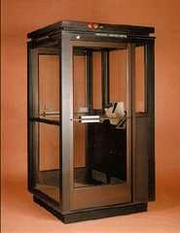
Room 8- Decontamination Chamber
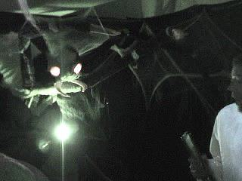
At the end of the Vortex Tunnel will be a square booth that has DECONTAMINATION CHAMBER and EMERGENCY, WARNING & BIOHAZARD signs all over it. It is the “Decontamination Chamber” that is used to clean people that may have gotten sprayed by spider venom. Unlike the photo shown here, the chamber will have opaque walls and be festooned with wires and pipes to increase the look and feel of an electromechanical device. The guide gets everyone into the room then hits a “start” button. An alarm klaxon(s) starts to ring and the room has a rotating police beacon in the ceiling. A calm, detached female voice will announce the decontamination sequence and make various announcements on status during the cycle. The room fills with fog as walls begin to shake with low frequency sweeping tones. The guide yells for everyone to hold onto the handles placed around the booth. The warning voice explains the decontamination process will “begin in 3.. 2.. 1” then air jets and strobes whip around the room as sirens wail. After a few repeats of this low frequency sound and air jet blasts, the air stops, the low frequency sound drops out and the voice announces “decontamination complete”. The exit door bursts open with a loud hiss of compressed air (possibly recorded).

Room 9- Giant Spider Reveal
After exiting the Decontamination Chamber, the guests should be somewhat disoriented and also have much decreased night vision. They exit from the chamber into an area bordered by a curtain with the “exit” doors clearly visible. The guide assures them they are decontaminated, and thanks them for coming out to the tour. It might be advantageous to have the guide drop “out of character” somewhat to re-enforce the feeling that the haunt is “over”. At the end of the “thank you” speech, the guide gives a cue phrase (“we have everything under control”) and a low, ominous growl rumbles out from the area behind the curtain drawing everyones attention to that direction. Then, the curtain drops to reveal a giant spider perched atop a slimy pile of giant green spider eggs pulsing with a sickly green glow.
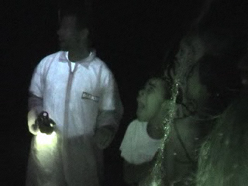
The spider begins to thrash and roar as “Spider Sliders” (actors in spider costumes) swarm out from around and behind the giant spider and head for the guests. (possibly, one actor will be suspended from the ceiling in rappelling gear and will swoop down from a perch near the giant spider and fly over the guests). The spider sliders would act as “pushers” and the guides would then start yelling for everyone to get out and would motion everyone towards the exit door. They open the doors, everyone runs out, the doors shut and the haunt is over. :)

Contact Information:
If you have any questions, please feel free to contact us using the following information:

Vern & Kimberley Graner
3006 Bee Caves Road
Suite B-160
Austin, Texas 78746-5540
Work Phone: 512-328-8947
Home Phone: 512-292-3454
Email Vern: vern@spiderspreyground.com
Email Kym: kym@spiderspreyground.com
Website: http://www.spiderspreyground.com
Most recent version of this document: http://www.spiderspreyground.com/docs

